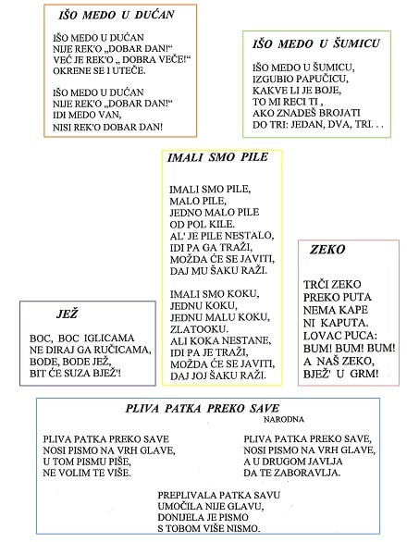
https://www.youtube.com/watch?v=B3sVTdVyJZk
https://www.youtube.com/watch?v=zSbSzOrcTwA
https://www.youtube.com/watch?v=MaOe5b9kQW0
https://www.youtube.com/watch?v=DtMs7RC_UrU
https://www.youtube.com/watch?v=iksddHAMr6Y
Ovo su brojalice koje trebate reproducirati te pokušati pjevati zajedno uz to matricu.
UŽIVAJTE UZ GLAZBU!

